**PIZZA SALES SQL QUERIES**

**A. KPI’s/** **Key Performance Indicators**

**1. Total Revenue:**

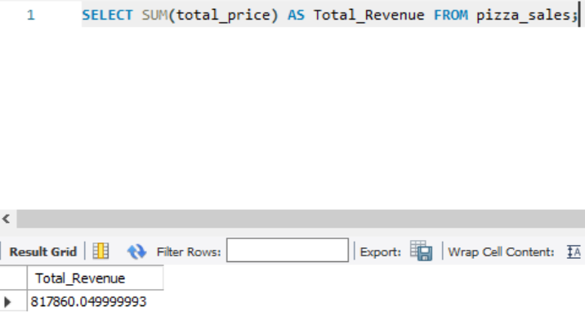

**2. Average Order Value**

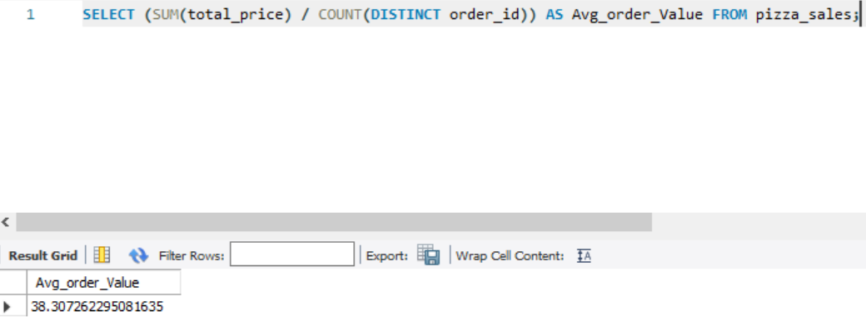

**3. Total Pizzas Sold**

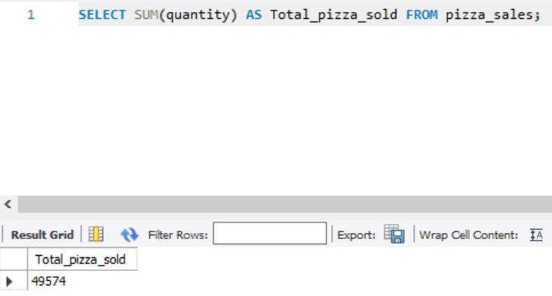

**4. Total Orders**

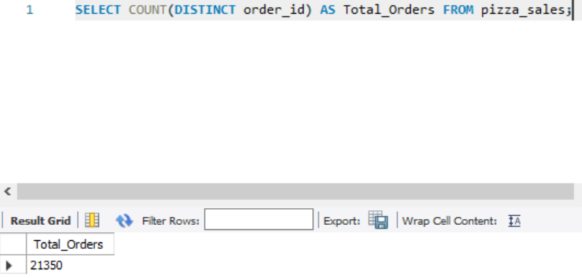

**5. Average Pizzas Per Order**

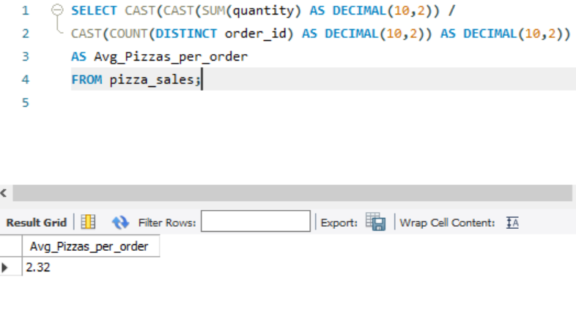

**B. Daily Trend for Total Orders  
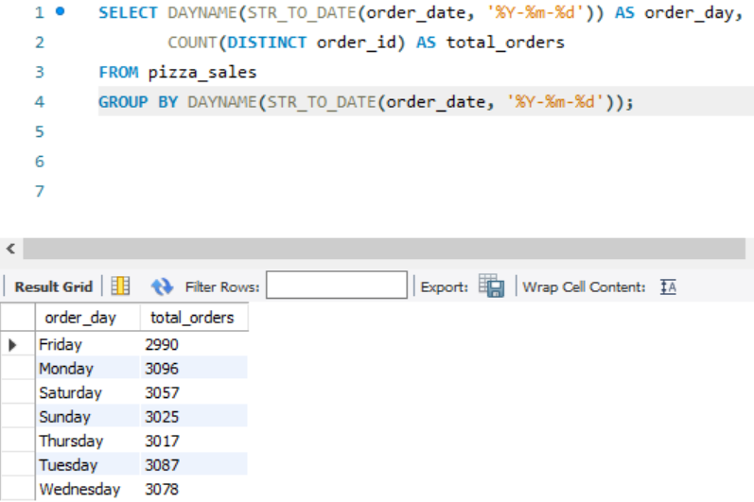**

**C. Hourly Trend for Orders**

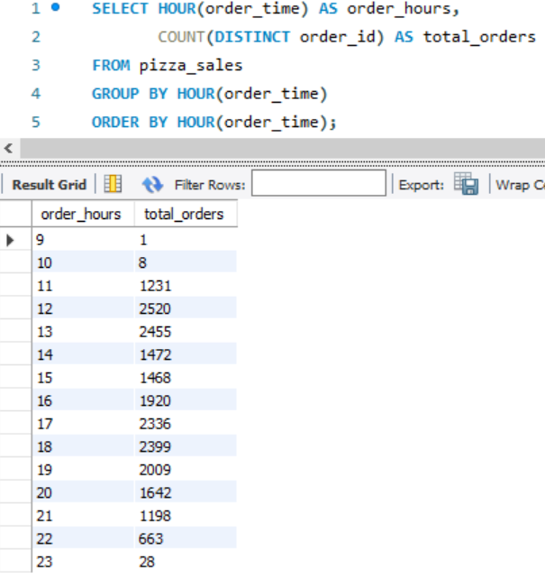

**D. % of Sales by Pizza Category**

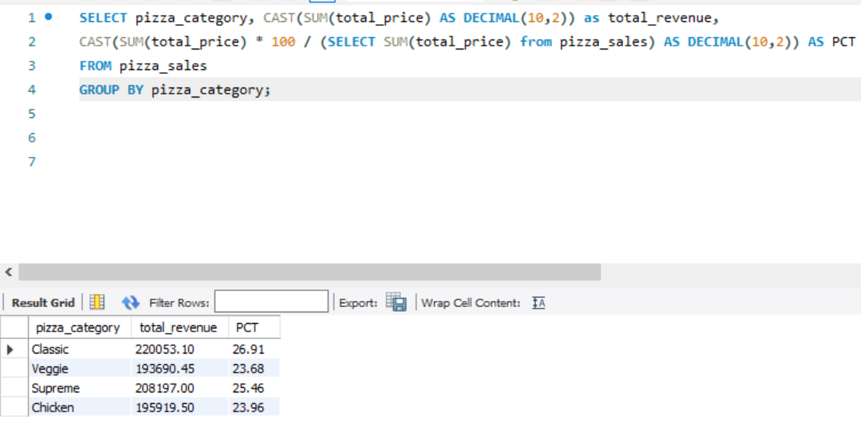

**E. % of Sales by Pizza Size**

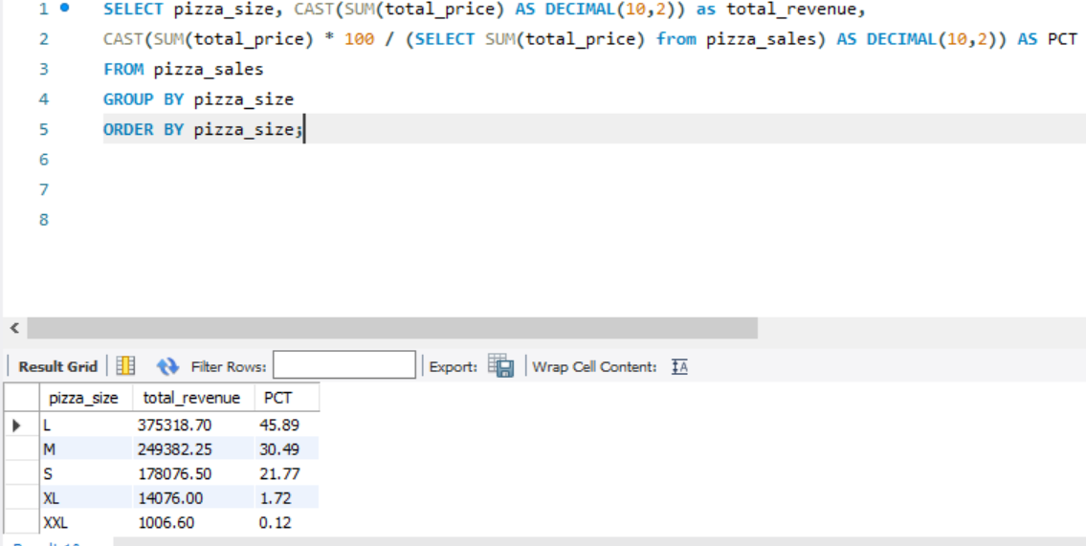

**F. Total Pizzas Sold by Pizza Category**

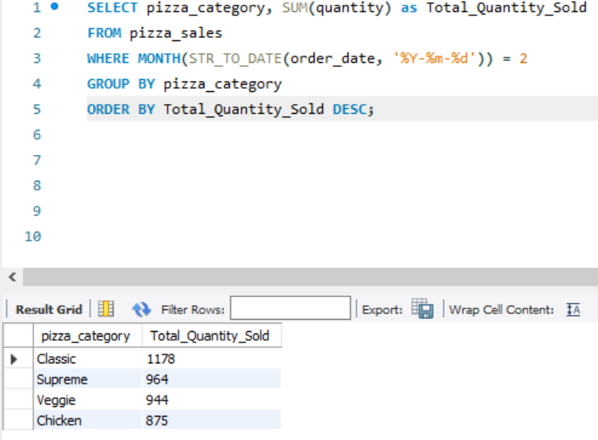

**G. Top 5 Best Sellers by Total Pizzas Sold**

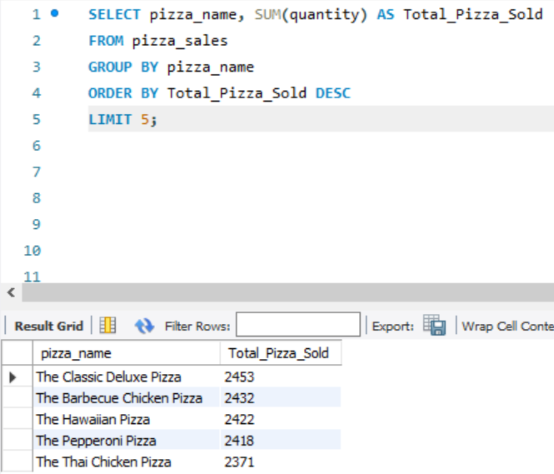

**H. Bottom 5 Best Sellers by Total Pizzas Sold**

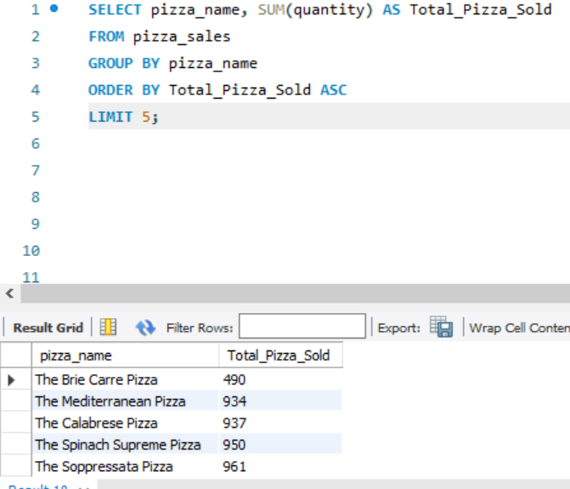

***NOTE***

If you want to apply the Month, Quarter, Week filters to the above queries you can use WHERE clause. Follow some of below examples

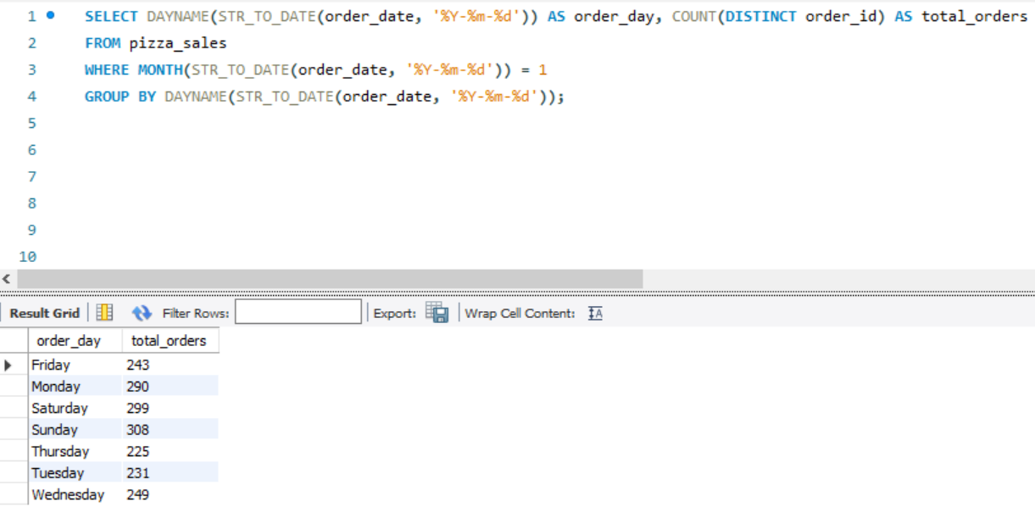

*\*Here MONTH(STR_TO_DATE(order_date, '%Y-%m-%d')) = 1 indicates that the output is for the month of January. MONTH(STR_TO_DATE(order_date, '%Y-%m-%d')) = 4 indicates output for Month of April.*

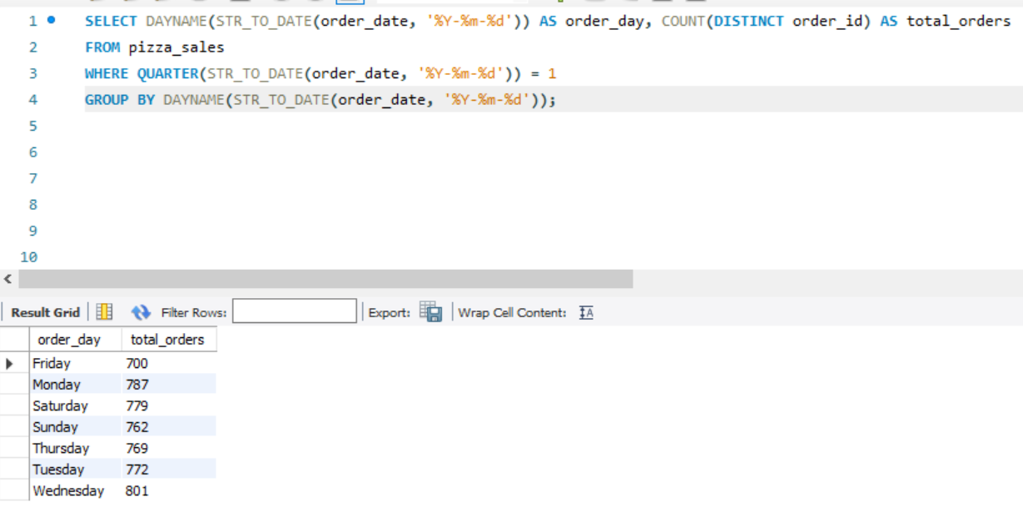

*\*Here QUARTER(STR_TO_DATE(order_date, '%Y-%m-%d')) = 1 indicates that the output is for the Quarter 1. QUARTER(STR_TO_DATE(order_date, '%Y-%m-%d')) = 3 indicates output for Quarter 3.*